<http://localhost:8087/mylms/student-register/>

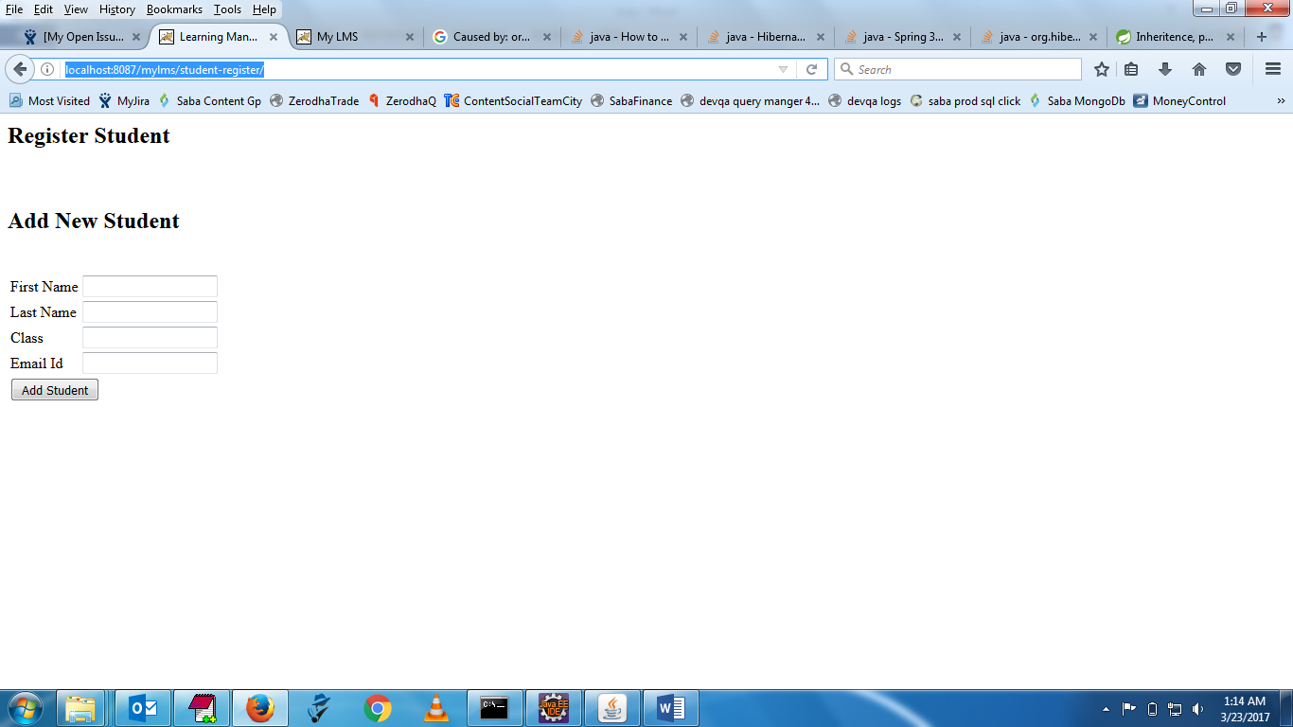

2)

<http://localhost:8087/mylms/home/>

